ML_Pipeline_Swagger UI_API

1. Project Summary
This FastAPI application serves a trained machine learning model that predicts whether an individual’s income is <=50K or >50K based on census-like features (age, education, occupation, hours worked, etc.). The API exposes two endpoints:
- GET / -> returns a welcome message to confirm the server is running.
- POST /predict -> accepts a JSON payload of features, processes the input using the trained encoder and model, and returns the prediction as a string label.

2. Instructions to Run
- Start the API server:
uvicorn main:app --reload
- Run the client script:
python local_api.py
- The client demonstrates both outcomes (<=50K and >50K).

3. Screenshots
Early Testing Results

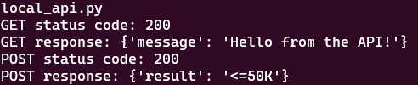

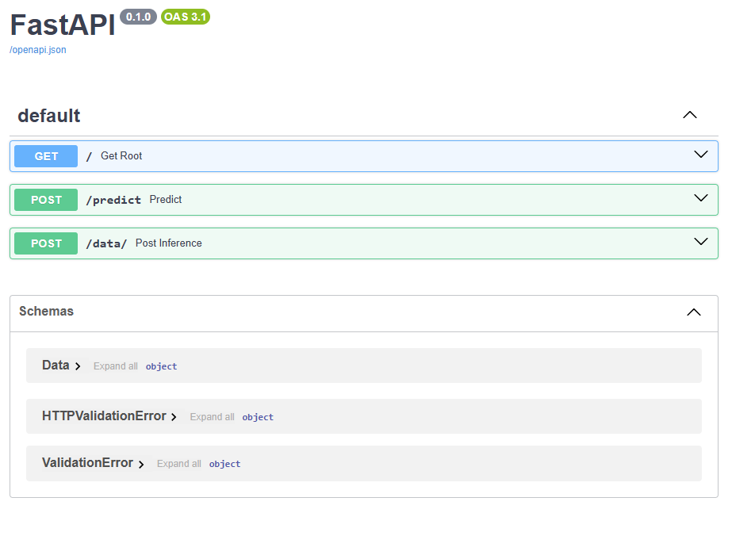

Completed Work
Local_api.py
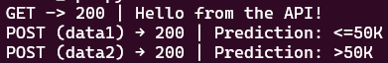
GET /
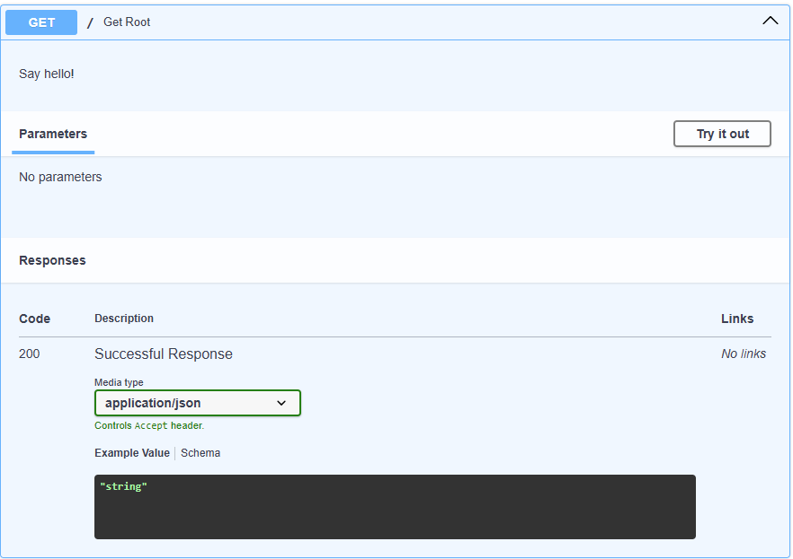

POST /predict with Data1 -> <50K
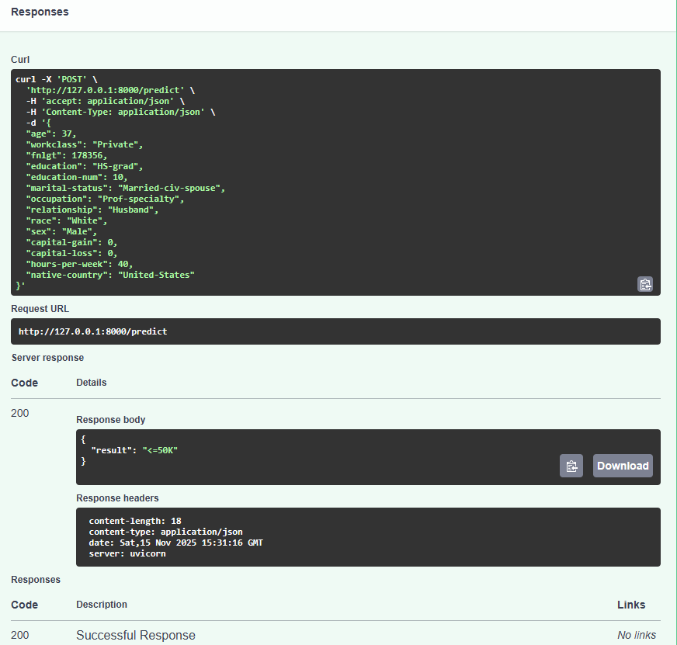

POST /predict with data2 -> >50K
